Game Design Document

Table of Contents

1 Overview 1

What is the project about? 1

What makes this project unique? 1

Visual & Gameplay Theme 1

2 Mechanics 1

2.1 System: Score 1

Earn points by 1

Lose points by 1

Leaderboard 1

2.2 System: Round 1

Key features: 1

Timer 1

2.3 Mechanic: Role-Switching 1

Visuals 1

Other features 1

2.4 Mechanic: Pick-ups 1

Key features 1

Types 1

Visuals 1

3 Characters 1

3.1 Character: Runner 1

Key features 1

Runner abilities and controls 1

3.1.1 Mechanic: Reeling 1

Functionality 1

The rope 1

3.1.2 Looks: Penguin 1

Visuals 1

VFX 1

Animation 1

3.2 Character: Cannoneer 1

Key features 1

Cannon abilities and controls 1

3.2.1 Mechanic: Cannon Shooting 1

Functionality 1

Projectile 1

3.2.2 Looks: Cannoneer penguin 1

Features: 1

The cannoneer penguin 1

The cannon 1

4 Levels 1

4.1 Location: Icy Plains 1

5 Technical 1

5.1 System: Game Engine 1

5.2 System: Platform Details 1

6 GUI 1

6.1 Menu: Start Menu 1

6.2 Menu: Penguin Selection Menu 1

Layout 1

Looks 1

6.2.1 Cutscene: Cannon assignment (stretch goal) 1

Scene 1

6.3 Menu: HUD 1

Layout 1

6.4 Menu: Settings Menu 1

Layout 1

Looks 1

6.5 Menu: End screen/Leaderboard 1

Layout 1

Looks 1

7 Business 1

7.1 System: Marketing 1

# 1 Overview

### What is the project about?

**Reel It In** is a chaotic 1v3 couch multiplayer game where players use a reeling mechanic to pull, push, work together and sabotage. One player controls a cannon, blasting the three runners, who must dodge, assist—or betray—each other using grappling hooks. Getting hit swaps your role, creating a fast-paced game of tag.

### What makes this project unique?

**Reeling Mechanic**: Core to movement and strategy, allowing for both control and chaos.  
**Role-Switching**: Keeps the game dynamic—no one stays in power for long.  
**Unpredictable Player Interaction**: Teamwork can save or doom you.  
**Couch Multiplayer Madness**: Built for local, fast-paced fun and mischief.

### Visual & Gameplay Theme

Set in an **icy Arctic world**, the game blends the round and bouncy penguin characters with the harshness of the environment. Penguins are notoriously awkward in their movements, and the slippery ice arena adds an extra challenge and fun to an already clumsy and chaotic movement mechanic. The fishing rod matches the setting, giving the game a cartoony animated feel while also being a core gameplay element.

At its core, Reel It In is about momentum, power shifts, and the fine line between teamwork and betrayal, all wrapped in a playful Arctic setting.



# 2 Mechanics

## 2.1 System: Score

Players will get ranked based on their **score**. The more time you have as the cannon, the **lower** your score will be.

### Earn points by

* **Saving** runners from the cannon's attack -> +15
* **Sabotaging** runners, reeling them into the radius of an attack -> +15
* **Surviving** as a runner for as long as you can -> +1 every **5 seconds**
* **Picking up** bonus items -> just the runners
* **Destroying Pick-Ups** -> just the cannon
  + Details about score points related to pick-ups at [Element Mechanic: Pick-ups](https://app.hacknplan.com/p/217307/gamemodel?nodeId=35&nodeTabId=1)
* **Hitting a runner as the cannon** -> +20
  + Hitting multiple runners means earning extra points -> +15 per extra player
  + Bonus points are earned if the cannon manages to tag another player within the first **15 seconds** of being tagged -> +15

### Lose points by

* Playing as the **cannon** -> your score will decrease over-time while playing as the cannon
  + the cannon loses -1 points every **2 seconds**
* Being the cannon when the **round ends** 
  + this will result in a -50 point penalty

### Leaderboard

* All scores will be displayed at the end of the round in a **Leaderboard**
  + Read more about the Leaderboard on [Element Menu: End screen/Leaderboard](https://app.hacknplan.com/p/217307/gamemodel?nodeId=32&nodeTabId=1)

## 2.2 System: Round

The game is played in **rounds**. After the round ends, you get the option to play more or quit the game.

### Key features:

* A round takes a fixed amount of time - 2 minutes
* The player that's controlling the cannon at the end of the round **loses**

### Timer

* The timer will **not** be a part of the UI, instead it will be integrated within the playfield
* The time remaining in the current round will be displayed as an **electronic timer** under the cannon

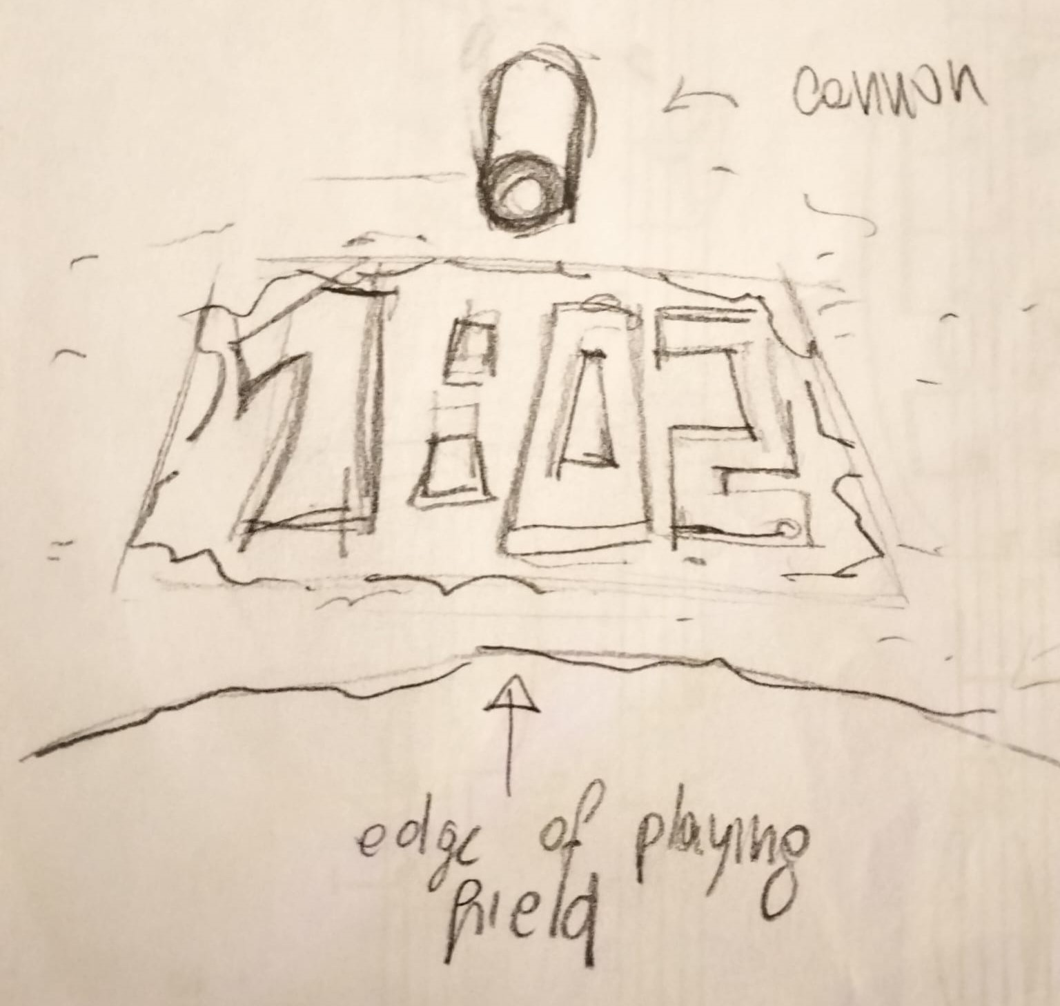

* When there are only 10 seconds left of the round, a **ticking sound** will start playing and the edges of the screen will gain a slight chromatic aberration and vignette effect, similar to this

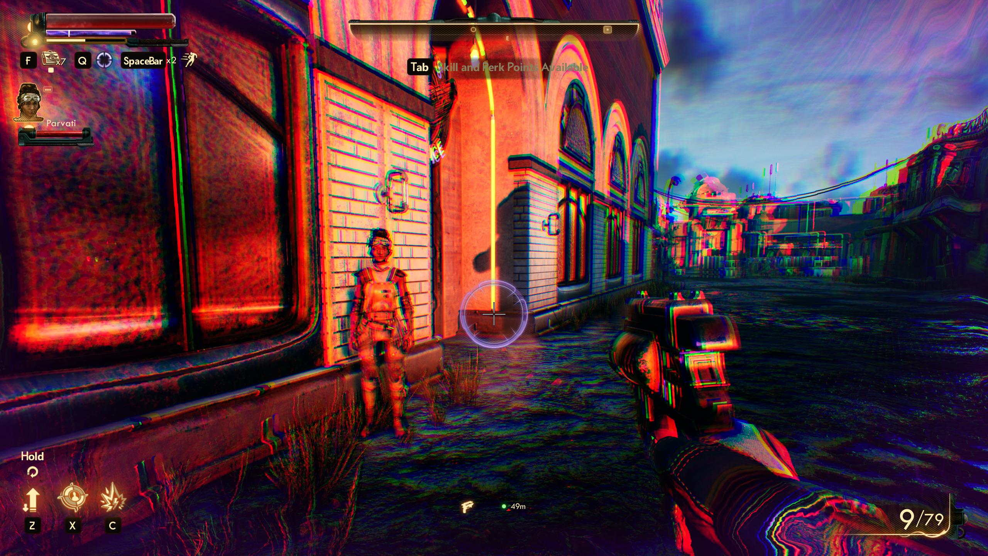

## 2.3 Mechanic: Role-Switching

One main mechanic in Reel It In is the tag aspect of the game. Each time a **runner** is hit by the **cannon**, they switch places.

### Visuals

* The player that is hit with the projectile will be **thrown off the map** before being able to control the cannon
* The hit player will play a **flying animation** while being thrown off
* The expression of the hit player will be **scared**
* The cannon will play a** laughing animation**
* After the hit runner is blown off the map and the other animations are done playing, the cannoneer and runner will switch places with the help of a **POOF** VFX, similar to:  
  

### Other features

* The spawn location of the *used-to-be* cannoneer will be the spawn point of his penguin
* A *poof* sounds will follow the *poof* VFX
* A sound will be played as soon as the two players switch places

## 2.4 Mechanic: Pick-ups

Pick-ups may **randomly** appear on the map at **random time intervals**.

### Key features

* A short popping sound is played whenever a pick-up spawns
* The pick-ups can be reeled in by **runners** for *bonus score* and *different buffs*
* The pick-ups may also be destroyed by the **cannon** for a *runner debuff* or *cannon buff* and *bonus score*
* **The same amount of bonus score** will be earned by the runners reeling in the pick-up, or the cannon destroying it
* Upon being reeled in, a **rewarding** sound will play
* Upon being destroyed, a **downgrade** sound will play

### Types

The pick-ups consist of the following types:

* Speed buff  
  -> increases the runners' speed by **20%**  
  -> lasts **10 seconds**  
  -> upon being **destroyed** by the cannon, **all runners** get **20%** slower for **10 seconds**  
  -> grants **+20** bonus score points
* Fishing rod upgrade  
  -> **cannot get defended** against  
  -> reels targets in **automatically**  
  -> lasts **10 seconds**  
  -> upon being **destroyed** by the cannon, **all runners** are left unable to reel for **5 seconds**  
  -> grants **+20** bonus score points
* Range buff  
  -> increases the runners' reeling range by **20%**  
  -> lasts **10 seconds**  
  -> upon being **destroyed** by the cannon, the cannon's attack range gets increased by **20%** for **10 seconds**  
  -> grants **+20** bonus score points
* Protection star  
  -> grants **immunity** for the next cannon hit  
  -> upon being **destroyed** by the cannon, **one runner** is randomly picked to replace the cannon  
  -> grants **+50** bonus score points

### Visuals

* there will be a different icon for each pick-up type, the items will be roughly the following:

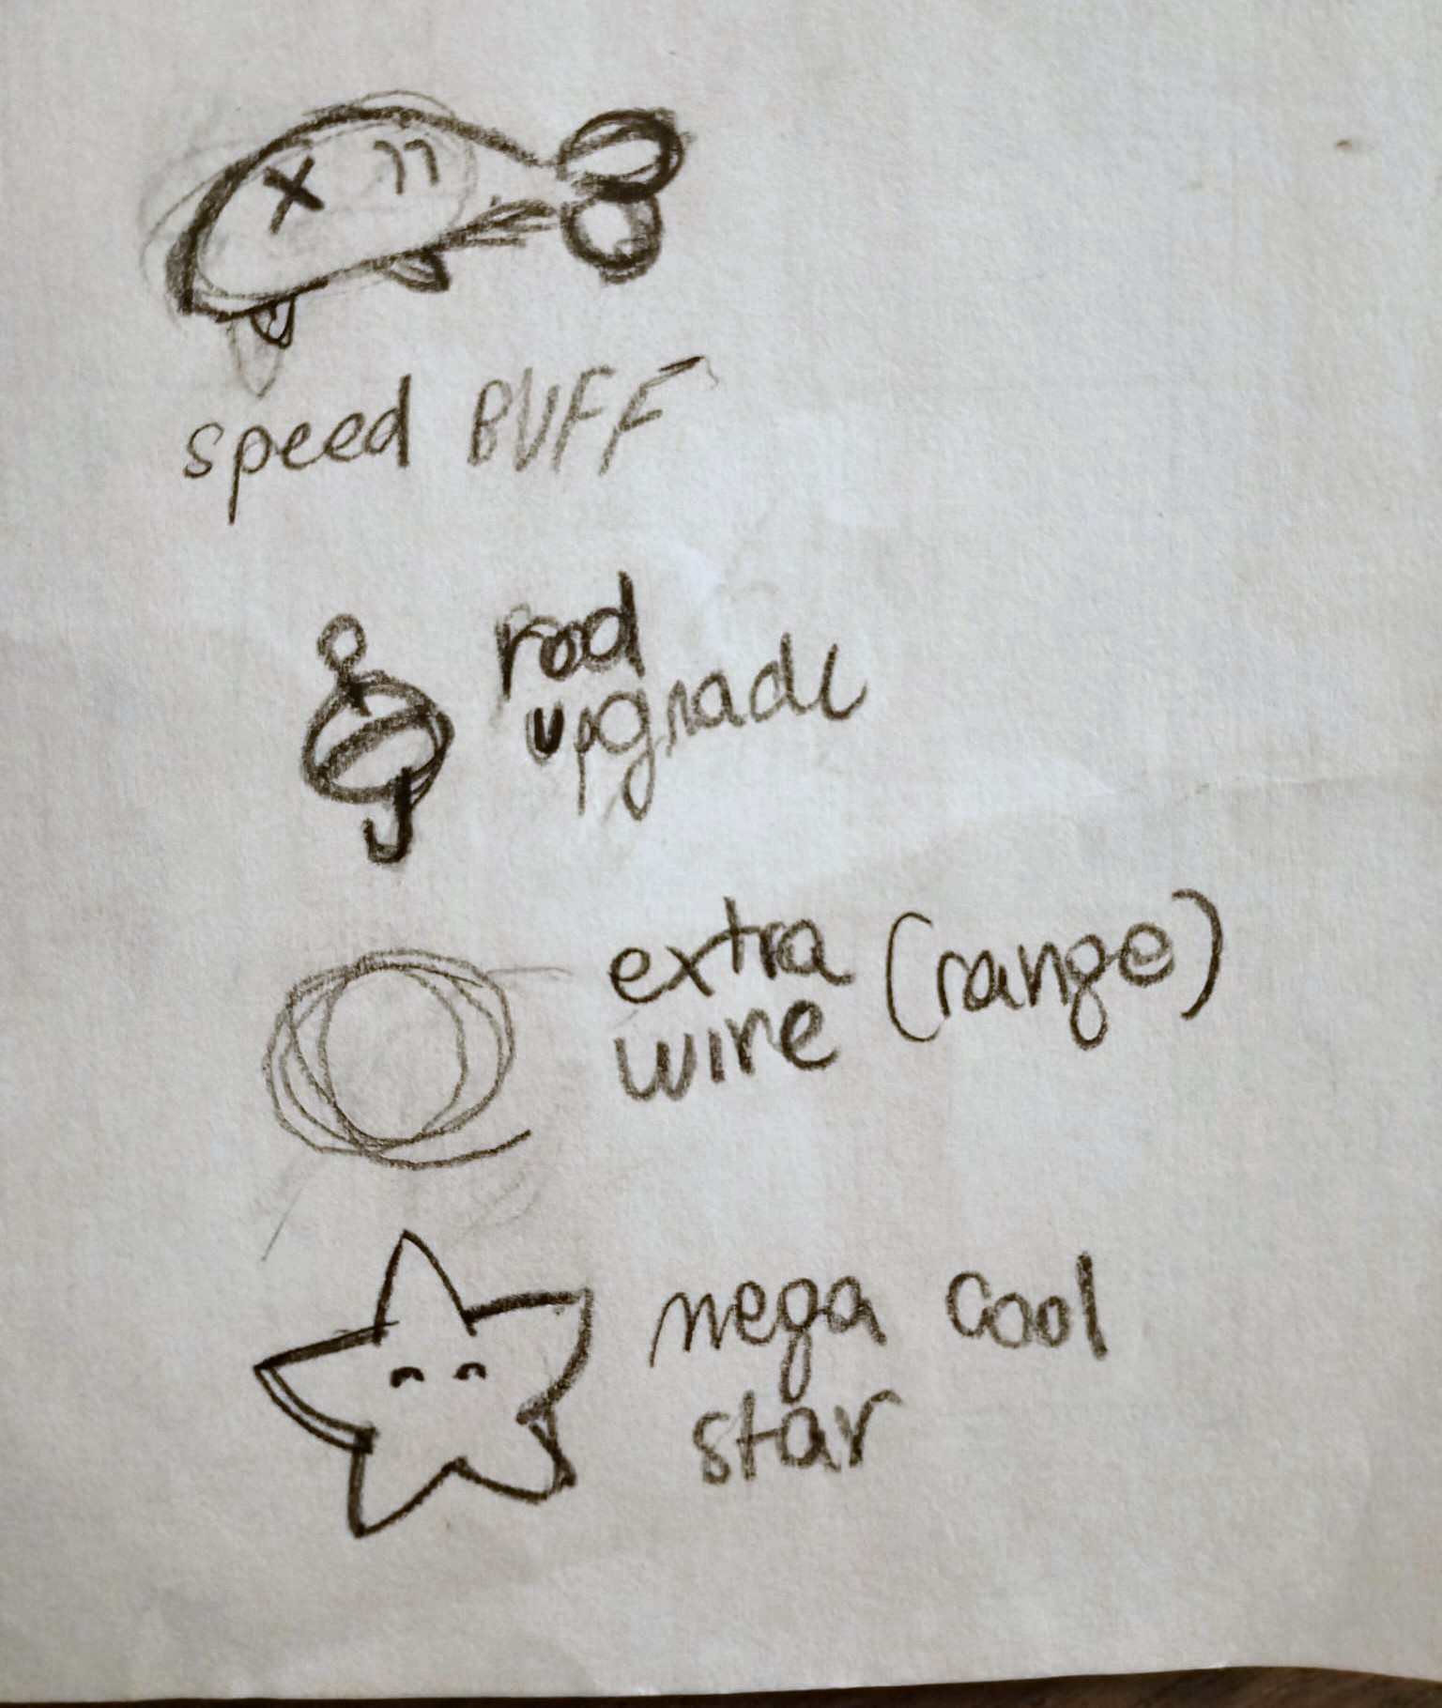

* each pick-up will have a shine-over effect similar to that of The Legend of Zelda pick-ups  
  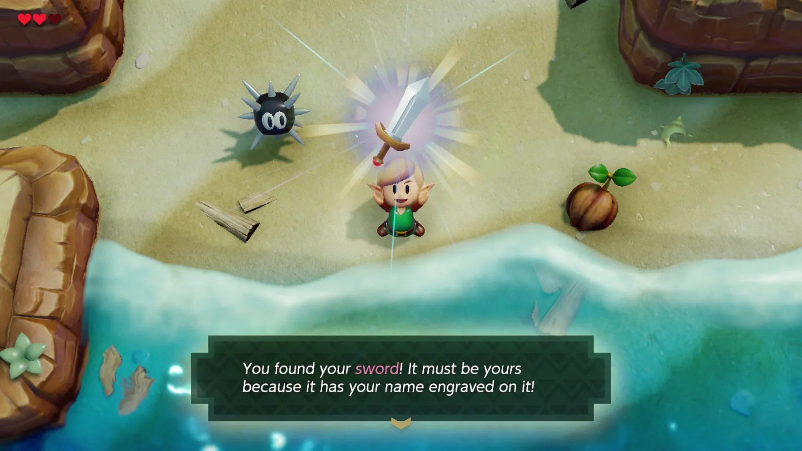
* the pick-ups will float slightly above the ground
* they will slightly move upwards and downwards, similar to the minecraft pick-ups (but without the rotation)  
  
* the pick-ups will cast a shadow
* Upon being destroyed by the cannon, a short-lived explosion VFX will replace the pick-up, similar to the following  
  

# 3 Characters

The penguins are the **playable characters** in game.

* Each player gets assigned a random penguin at the start of the game.
* The penguins can be of two different types: [Element Character: Runner](https://app.hacknplan.com/p/217307/gamemodel?nodeId=19&nodeTabId=1) or [Element Character: Cannoneer](https://app.hacknplan.com/p/217307/gamemodel?nodeId=9&nodeTabId=1) .
* There will be 4 different penguin models

## 3.1 Character: Runner

### Key features

* The runner is a **playable character**.
* There can be up to 3 runners active at the same time
* The runners have to **avoid** the cannon's attacks
* Upon being hit by the cannon, the hit player and cannon will switch roles: the hit player now controls the cannon
  + more on roles switching at [Element Mechanic: Role-Switching](https://app.hacknplan.com/p/217307/gamemodel?nodeId=23&nodeTabId=1)
* Each runner possesses a **fishing rod**
* The visuals of the runners are explained at [Element Looks: Penguin](https://app.hacknplan.com/p/217307/gamemodel?nodeId=29&nodeTabId=1)

### Runner abilities and controls

* Move in all directions -> left joystick
* The runner's movement is impeded by momentum due to the ice floor
  + They will **start moving slowly** and **grow faster** with time
  + It should be hard to turn once you start moving a direction monument should take you forward. This way the cannon could predict where the runners are going.
  + When turning while running, inertia force is applied so the runner will keep sliding in the previous direction for a bit before turning.
* Once a runners is reeled they can change direction towards the reeller and start sliding fast.
* The reeling mechanic is more thoroughly explained at [Element Mechanic: Reeling](https://app.hacknplan.com/p/217307/gamemodel?nodeId=20&nodeTabId=1), but here is an overview of the controls:
  + Aim the fishing rod -> right joystick
  + Shoot the hook -> right trigger
  + Reel hit target in -> right trigger
  + Defend -> A

### 3.1.1 Mechanic: Reeling

Reeling is the **main mechanic** of Reel It In. It can only be used by the *Runners* - [Element Character: Runner](https://app.hacknplan.com/p/217307/gamemodel?nodeId=19&nodeTabId=1)

### Functionality

Upon getting reeled, the target is **pulled** towards the player that reeled him.

#### Aiming:

* The runner aims the fishing rod towards the closest **hookable target** -> right joystick
* A hookable object will be searched within a cone detection radius in front of the runner
* If a valid item is found, a **target icon** the *same color* as the runner is shown on the object
* If multiple valid items are within range, the **closest** one is selected.
* If no valid item is found, no target icon will be shown, and reeling won't work

#### Valid targets

* The other runners
* Pick-ups -> [Element Mechanic: Pick-ups](https://app.hacknplan.com/p/217307/gamemodel?nodeId=35&nodeTabId=1)

#### Hooking & Reeling:

* Shoot the hook by **pressing** the primary fire button -> right trigger
  + Missing the target is **possible**
  + The further the target is, the longer it takes to reach, and the higher the chance of **missing**
  + A **throwing sound** will be played
* To reel in the target you need to press the fire button at the right time once the hook is on the target -> right trigger
  + If the fire button is pressed *before the hook reached target*, the hook will start **retracting**, thus leaving the target unhooked
  + If the fire button is pressed_ too late after reaching target_, the reeling force will be **minimal**
  + If the fire button is pressed at the right time the target will be reeled in
  + A **reeling sound** will be played
* If two players are trying to hook the **same target** at the **same time**, the rope that reaches target first will hook, while the other player's rope will start retracting and **will not hook**
* Upon reeling in a target, the reeler gets pushed towards the target a bit as well, due to the ice physics
* When a rope gets retracted **without** the target, a **whoosh sound** is played

#### Defending Against Reeling:

* When hooking another runner, the hooked player gets a chance to **defend**
* A **short-timed pop-up** appears, urging the player to press A if they wish to defend
* If the **hooked player** defends successfully, the **hooking player** gets reeled in instead
* **Defending is impossible**  if the hooked player is already in the process of hooking/reeling another target
* Upon successfully defending, a **shielding sound** is played

### The rope

* The rope thrown will **NOT** use physics, instead it will follow the trajectory of a [*Bezier curve*](https://en.wikipedia.org/wiki/B%C3%A9zier_curve) for better customizability
* After reaching the target, the rope will start "falling" till it matches another *Bezier curve*, that is used solely for the fall position
  + The "fall" of the rope is achieved by applying the force of gravity to each point in the rope until they reach a point on the *fall curve*
* Reeling the rope in will be done following another *Bezier curve*: the **pull curve**
* Each curve will be exposed to the editor for ease of customizability
* Other variables that can contribute to the trajectory of the rope over time, like the speed, should be added as a *Bezier curve* as well, and be **exposed to the editor**

#### Example

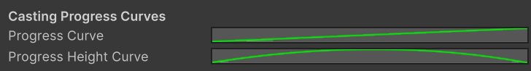

#### Structure

* **Throw Curve**
  + Progress Height Curve
  + Progress Speed Curve (optional)
* *Spacing*
* **Fall curve**
  + Progress Height Curve
  + Progress Speed Curve (optional)
* *Spacing*
* **Pull curve**
  + Progress Height Curve
  + Progress Speed Curve (optional)

### 3.1.2 Looks: Penguin

### Visuals

The penguin characters will be slightly different looking but all following some general shape language conventions:

1. soft, **round silhouette**
2. fins and feet **detached** from the body
3. an extra addition to the main body, such as a **hat or a scarf.**
4. the player with the **highest score** will wear a **crown**

These are some examples of different player silhouettes.  
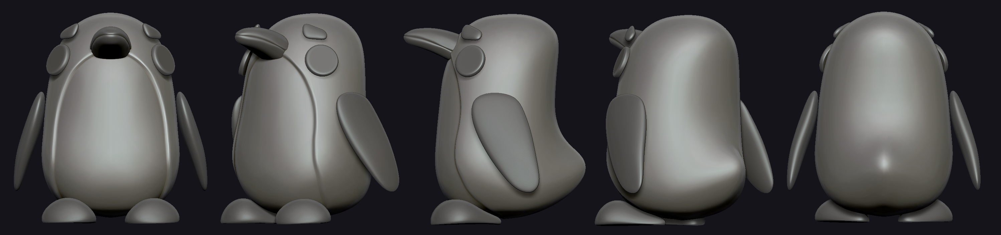  
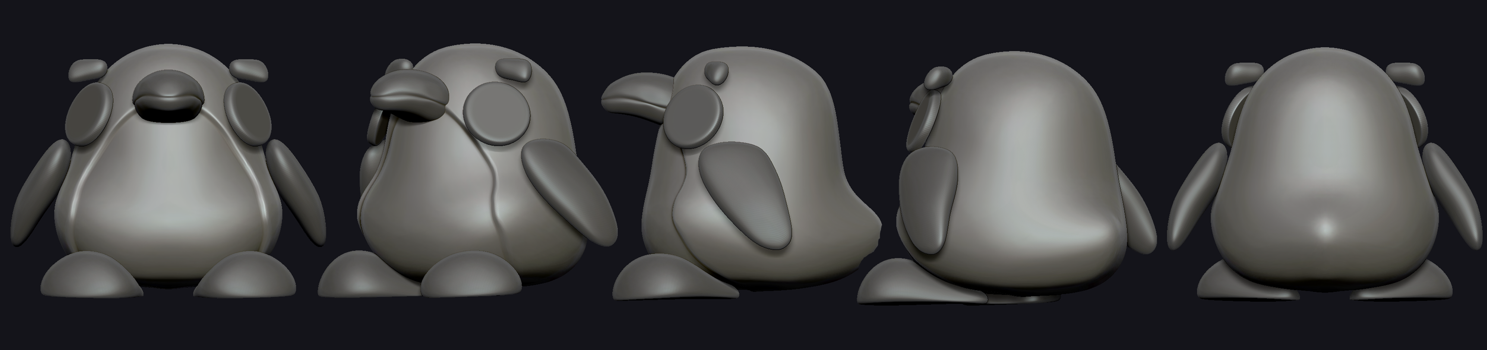  
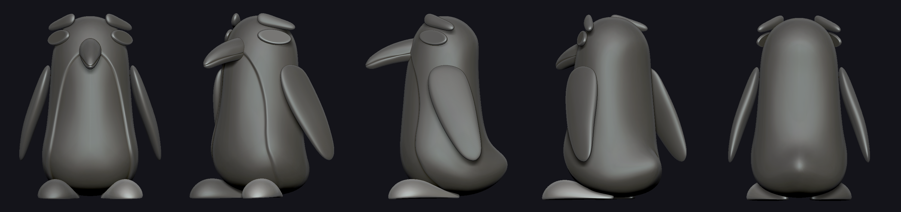  
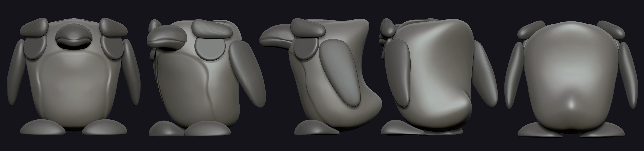

* Each penguin is also color coded differently from the other. There are a few palettes to choose from. The chosen colors will have a soft gradient applied to the body.  
  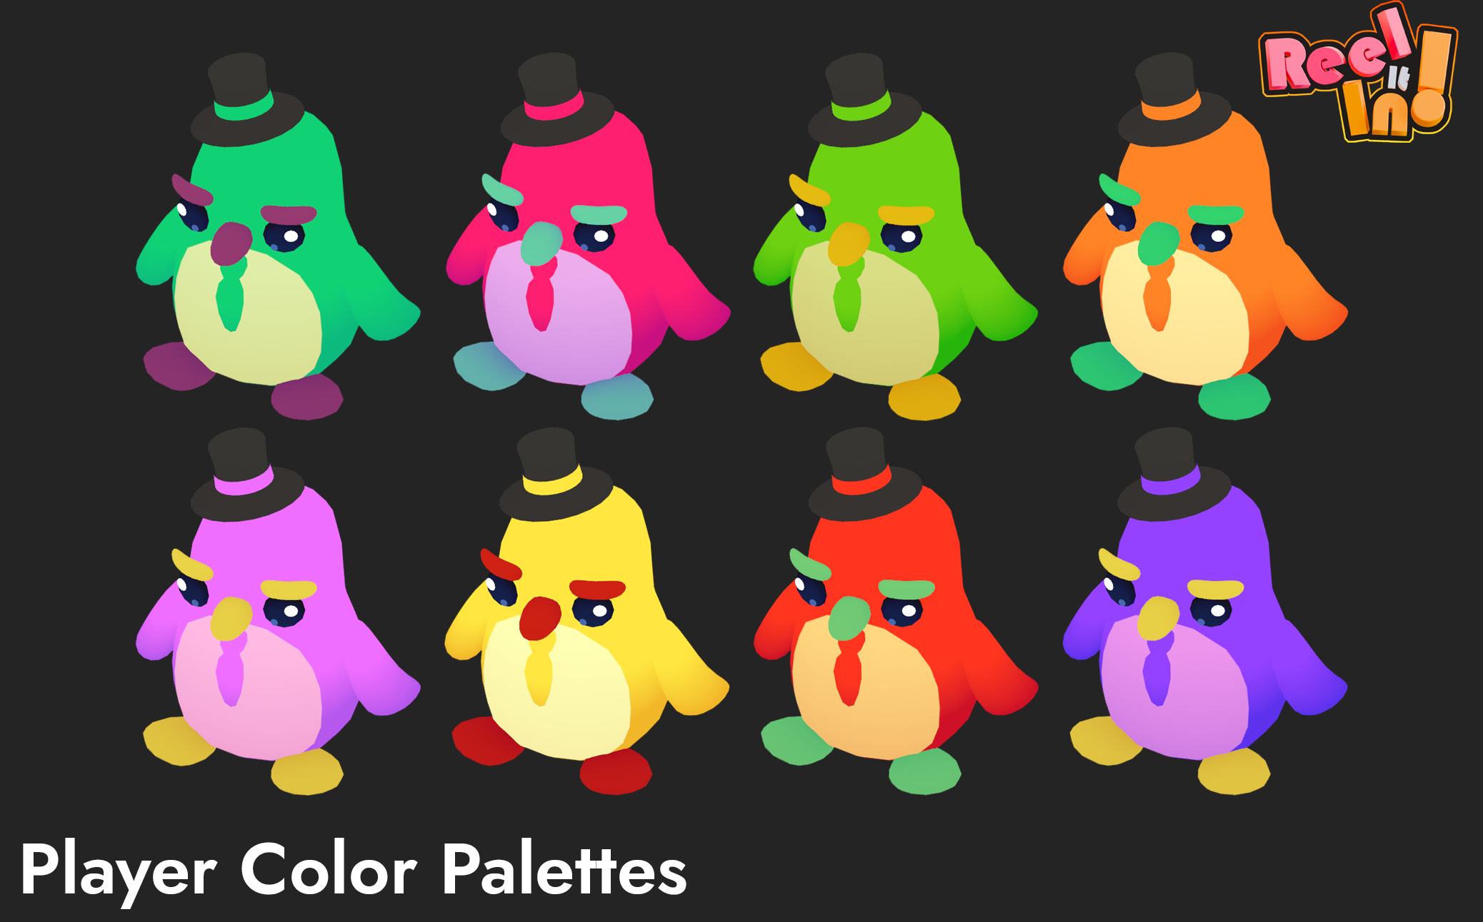  
  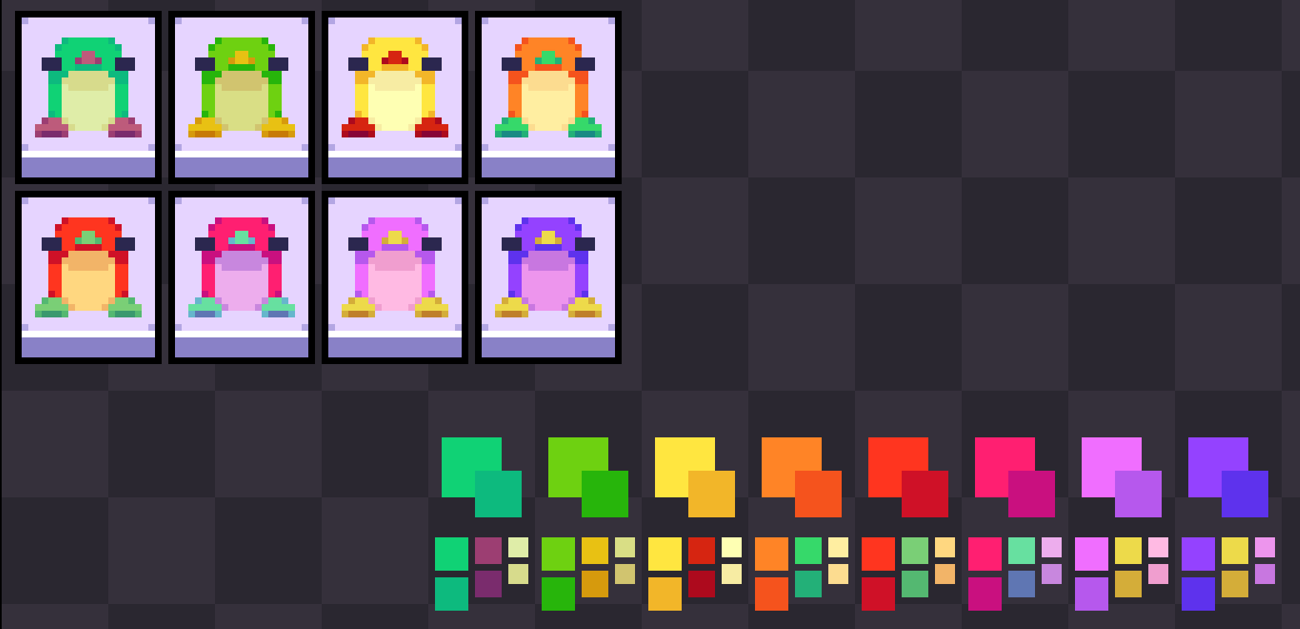

### VFX

While walking, the players will leave a small footprint trail, the prints are blue and shaped like the penguin feet.

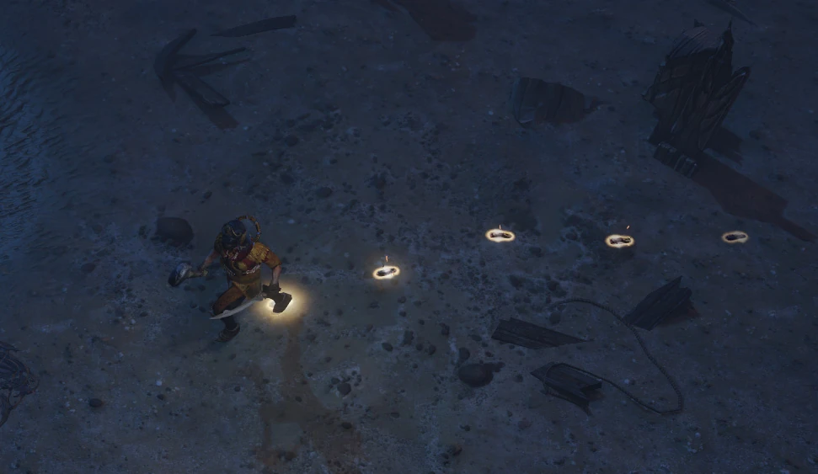

When they get target locked from other player a small poof effect appear for a second, together with an exclamation mark overing overhead,

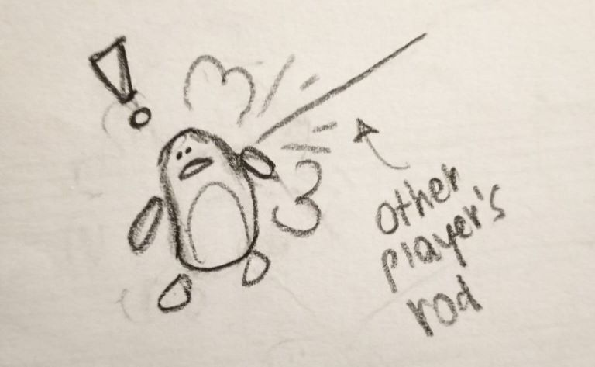

### Animation

The penguins will move around the screen either by **waddling** , or getting reeled. When they get reeled from more than a 5m distance, they slide on their bellies.  
The penguins' movement is **clumsy** and exaggerated. They give off a sense of struggle with their actions.

  


The only way for them to feel agile is when they get reeled in.



## 3.2 Character: Cannoneer

### Key features

* The cannoneer is a **playable character**.
* The cannoneer is unique: only one player will control it
* The cannoneer will **fight** against the other 3 players
* Upon hitting another player, the hit player and cannoneer will switch roles: the hit player now controls the cannon
  + more on roles switching at [Element Mechanic: Role-Switching](https://app.hacknplan.com/p/217307/gamemodel?nodeId=23&nodeTabId=1)
* There will **always** be one cannoneer
* The cannoneer is static: it cannot move
* Since every round has a **time limit**, the player that is the cannon by the end of the time **loses**
  + more on rounds at [Element System: Round](https://app.hacknplan.com/p/217307/gamemodel?nodeId=15&nodeTabId=1)
* More cannon time means a lower score
  + more on scores at [Element System: Score](https://app.hacknplan.com/p/217307/gamemodel?nodeId=24&nodeTabId=1)

### Cannon abilities and controls

The cannon's main ability is shooting a projectile and is more thoroughly described at [Element Mechanic: Cannon Shooting](https://app.hacknplan.com/p/217307/gamemodel?nodeId=26&nodeTabId=1) , but the main controls will be mentioned below:

* **Aim** the cannon -> right joystick
* Shoot the projectiles using the primary fire button -> right trigger

### 3.2.1 Mechanic: Cannon Shooting

### Functionality

* The cannon aims by looking around the map -> right joystick.
  + Whenever a player is aiming the cannon, a **target** is shown on the level.
* The cannon fires projectiles using the **primary fire button** -> right trigger.
  + The cannon's target indicator gradually **brightens and fills up** as the projectile gets closer, signaling nearby players to escape quickly.
  + There is a loud shooting sound played every time the cannon fires.
* After firing, there is a **cooldown** of 1 second before the next shot can be fired.
* When the cannon fires, an **ice particle effect** and an **ice shatter sound** are played.
* A slightly less powerful **screen shake** is triggered upon firing.  
  
* When a runner is hit, the cannon and runner **switch places** .
* When the projectile hits **multiple players**, the player closest to the center of the projectile is picked to be the new cannon controller, the other **cannot move for 3 seconds**.
* A pick-up object can also be shot and destroyed by the cannon. More on the effects of destroying a pick-up at [Element Mechanic: Pick-ups](https://app.hacknplan.com/p/217307/gamemodel?nodeId=35&nodeTabId=1) .

### Projectile

* The projectile is like a **mortar**.
* After** 2 seconds **the projectile will land and hit any runner that is in the radius.
* There is a particle effect similar to the one below triggered once the projectile reaches the ground.  
  

### 3.2.2 Looks: Cannoneer penguin

The cannoneer is a variation of the penguin character, which occurs only when the player is in the cannon role.

### Features:

* The cannoneer is made of two elements:

1. The cannon
2. The cannoneer penguin.

### The cannoneer penguin

* The cannoneer ** can't move** freely around the map.
* The cannoneer penguin moves side to side **behind the cannon**, following the opposite angle of the shooting parable.

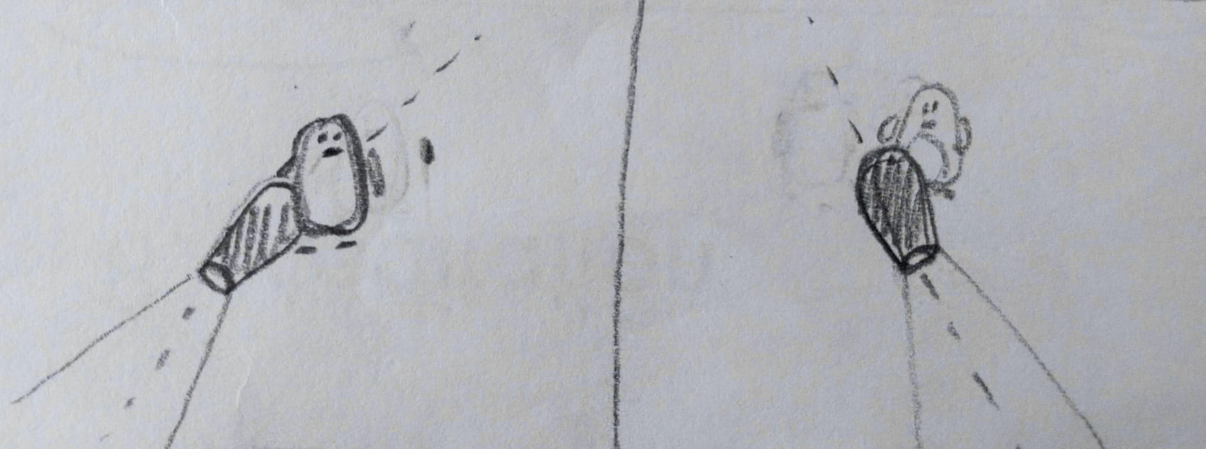

* The cannoneer penguin looks like the player's chosen penguin character with the addition of an **angry face** expression.
  + Refer to [Element Looks: Penguin](https://app.hacknplan.com/p/217307/gamemodel?nodeId=29&nodeTabId=1) for each penguin's looks
* If the cannon is still for too long, the cannoneer penguin will be animated with an **idle cycle** of the following actions:

1. wave at the screen
2. look around with a fin over his eyes
3. take out a pair of binoculars to look at the field

* The cannoneer switches to and from the playing field with a **teleport effect** more thoroughly explained at [Element Mechanic: Role-Switching](https://app.hacknplan.com/p/217307/gamemodel?nodeId=23&nodeTabId=1)

### The cannon

* The cannon is **chunky and slightly covered in snow**.
* When the player is aiming the cannon is **slightly squashed**.
* When the player fires a shot the cannon stretches back to normal and shakes slightly.

# 4 Levels

## 4.1 Location: Icy Plains

**This is the main level of the game.**

* **Goofy** music will play on the background.

#### Elements that make up the level:

* RED The frozen lake in the middle used as our playing field
  + this part consists of ice that **breaks** if the cannon hits it too many times
  + it will keep the runners on their toes and make it easier for the cannon to hit the players
  + The runners can only move here
* GREEN **The cannon platform** that is used for the cannon to move and shoot on
* BLUE Background foliage to make the background of the level more interesting
* YELLOW Different assets and props on both sides to make the level more lively and less empty the runners can't walk here
* PURPLE/PINK Placeholder for future UI elements
  + more about the HUD at [Element Menu: HUD](https://app.hacknplan.com/p/217307/gamemodel?nodeId=30&nodeTabId=1)

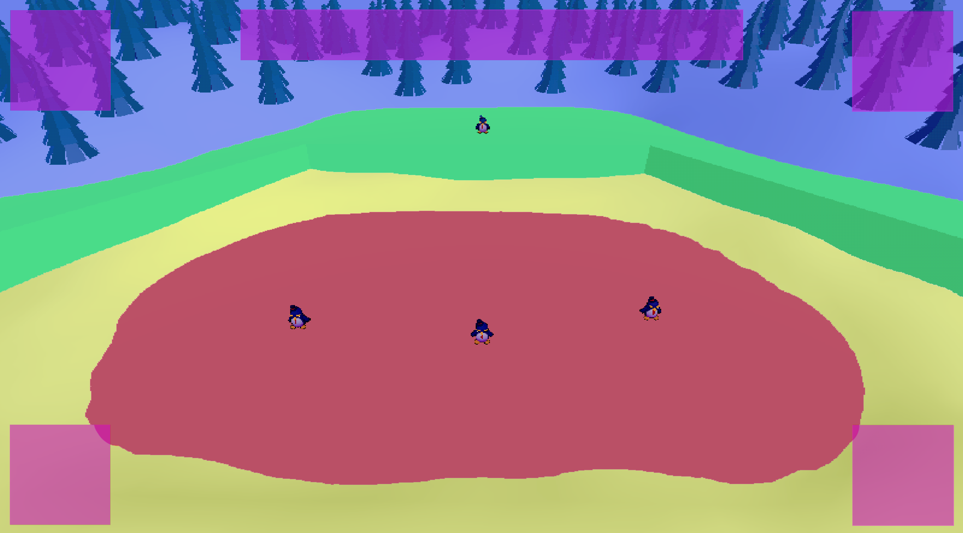  
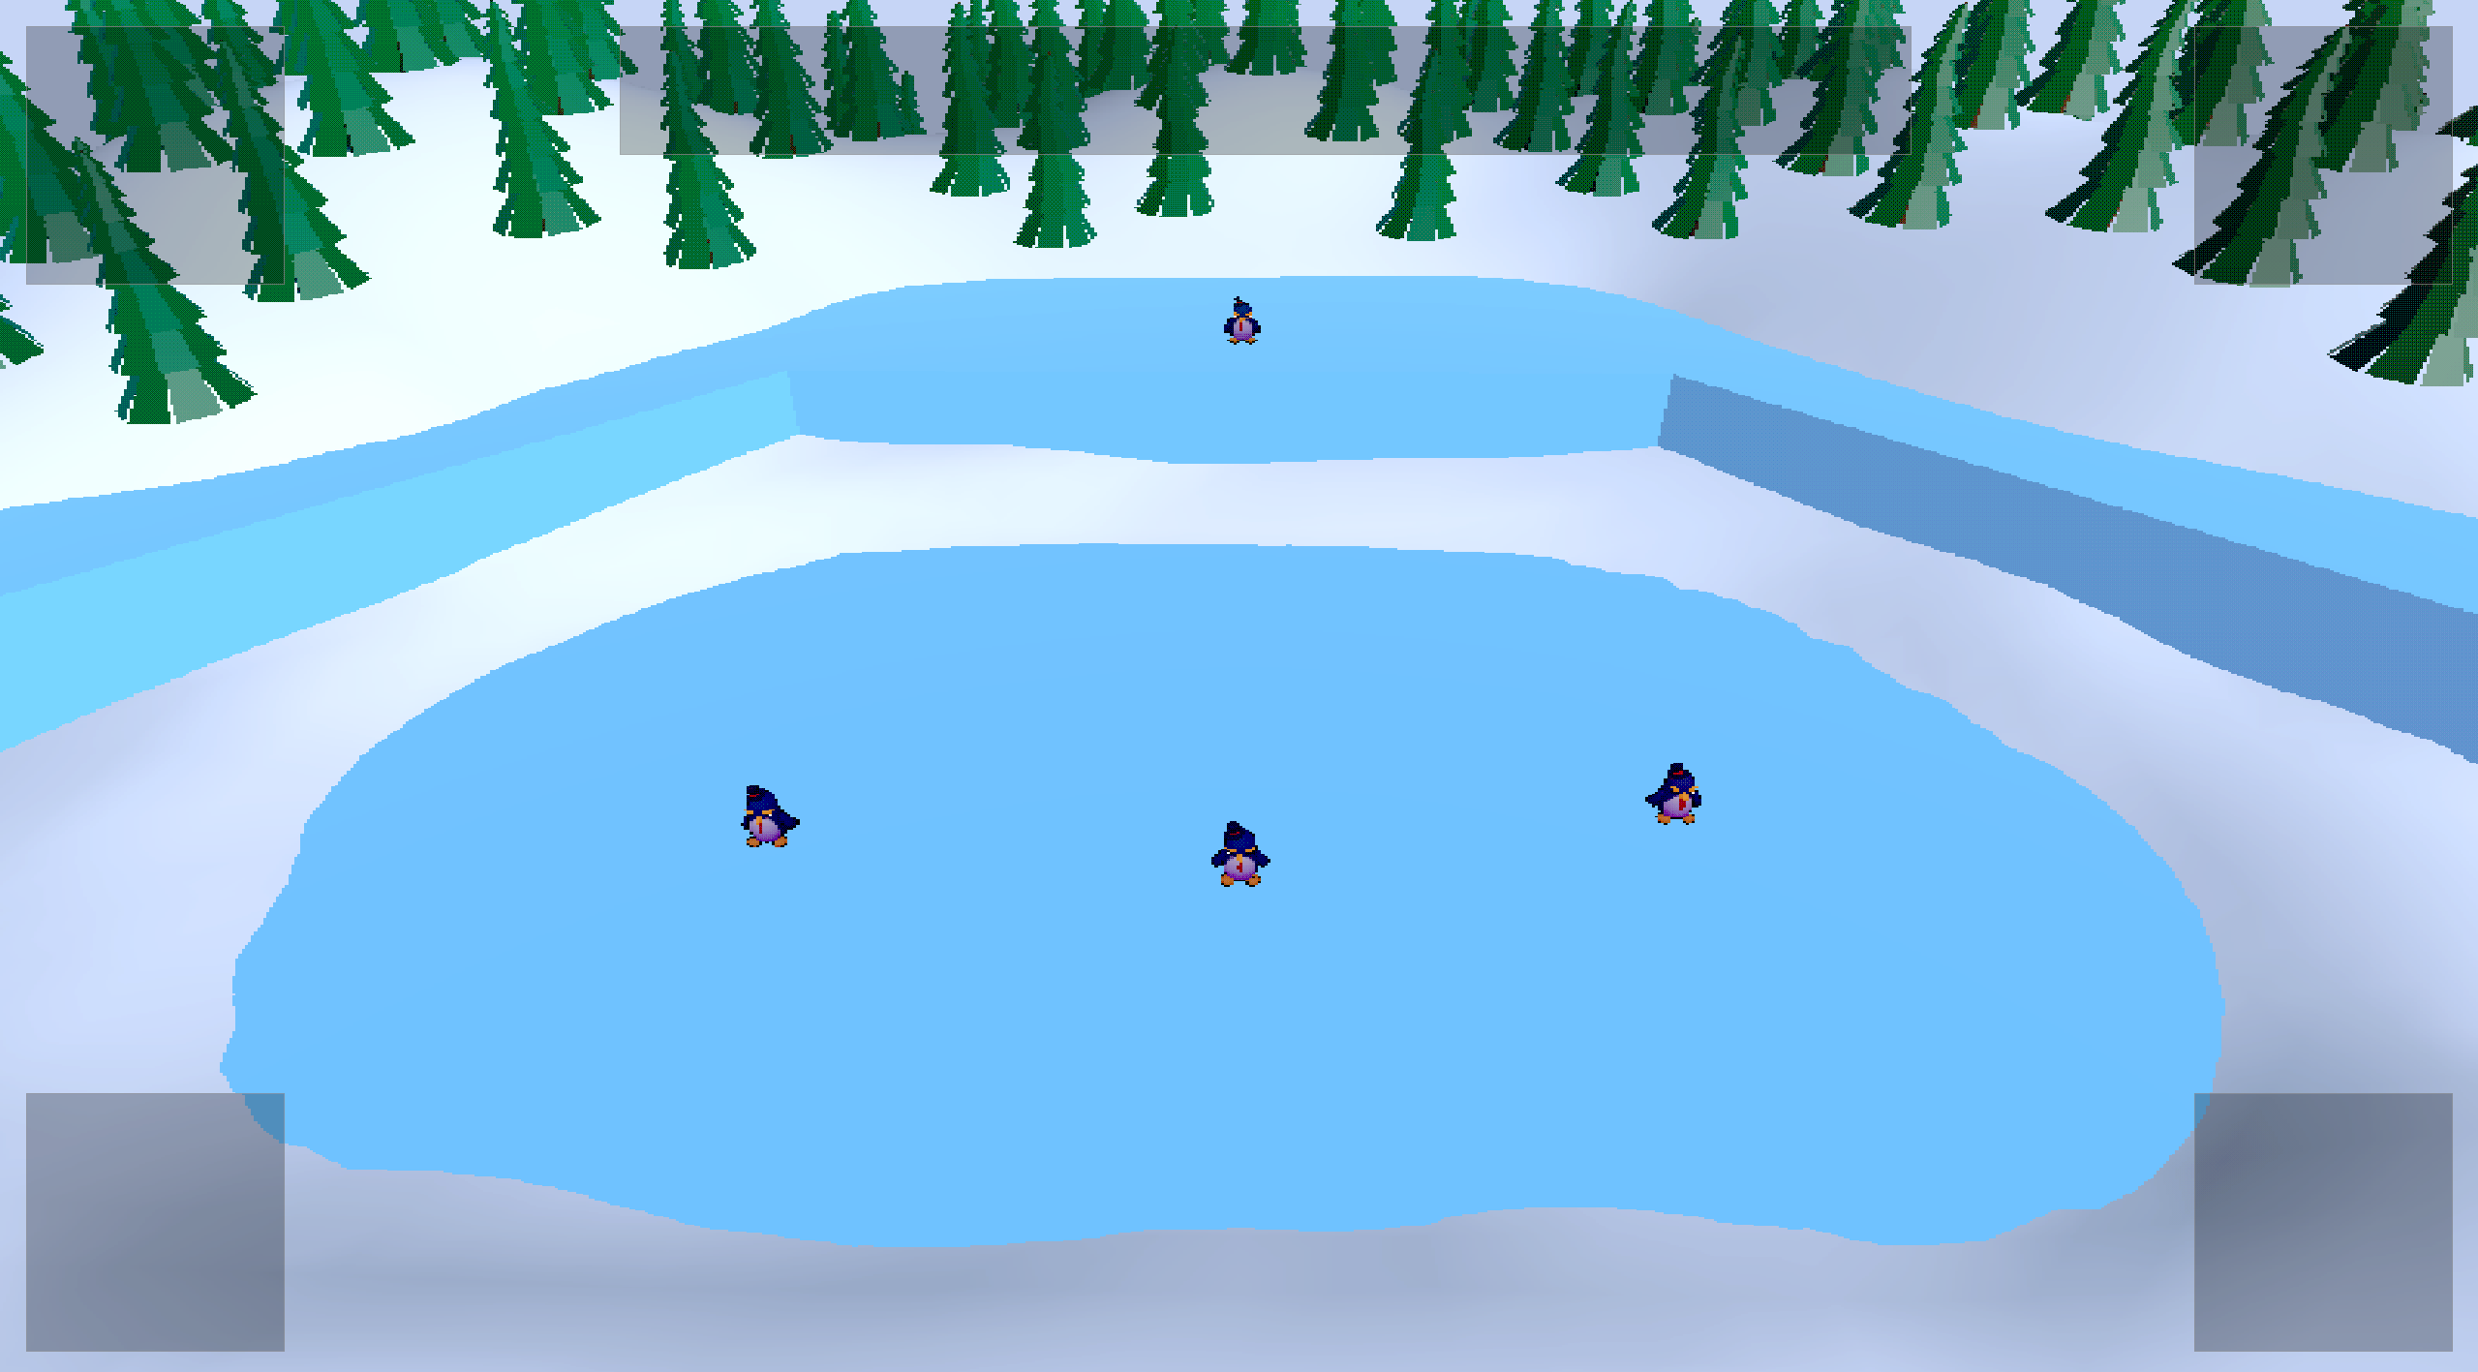

# 5 Technical

## 5.1 System: Game Engine

For the game engine we use **Unity URP** for the following reasons:

* **Great for stylized games** – Unity makes it easier to achieve a cartoonish look.
* **Simpler workflow** – Learning and working in Unity is more straightforward.
* **Less unnecessary complexity** – Unreal comes with many advanced features we don’t need.
* **Customizable systems** – Unity allows us to write our own physics and gameplay logic more easily.
* **Strong documentation & tutorials** – Unity’s resources make problem-solving faster.

## 5.2 System: Platform Details

We mainly develop on and for **Windows** systems. However, we do provide **Xbox controller support**. In fact, the game is designed to be played with controllers because it is a couch party game.

# 6 GUI

## 6.1 Menu: Start Menu

The start menu is the first introduction that our player has with our game. It therefore needs to represent what we want to convey with our project: **fun and chaos.**

#### Layout

The layout will be **essential** and straight to the point. We will not make a game that requires multiple save slots or extra game modes, and our menu should also reflect the project when it comes to scope.  
The menu consist of 3 buttons:

1. Start game -> Leads to the [Element Menu: Penguin Selection Menu](https://app.hacknplan.com/p/217307/gamemodel?nodeId=33&nodeTabId=1)
2. Settings -> Leads to the [Element Menu: Settings Menu](https://app.hacknplan.com/p/217307/gamemodel?nodeId=31&nodeTabId=1)
3. Exit game -> Quits the game

The font will be** round and bouncy**, the icons can be slightly tilted.  
Here are some font examples.  
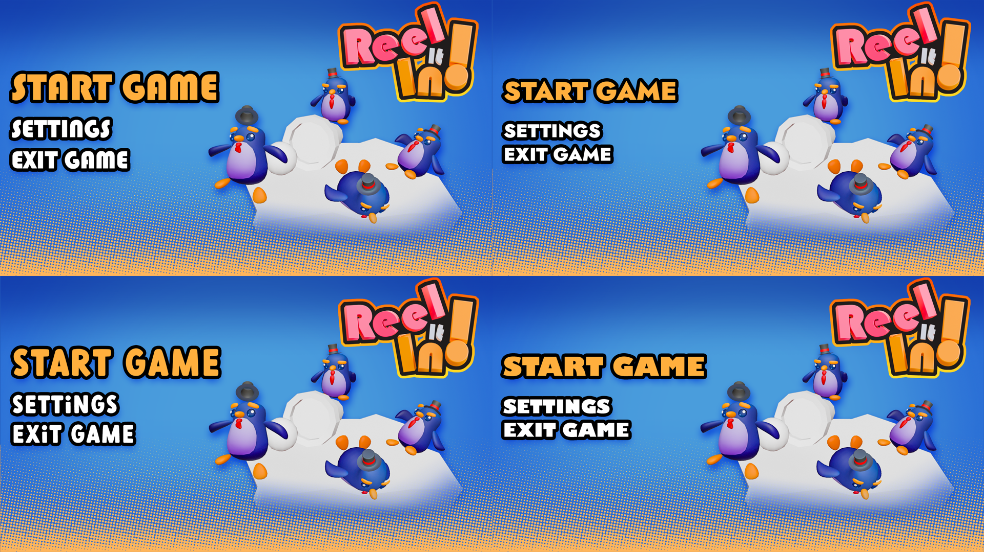

#### Looks:

The main menu features all the key components of the game: the **penguins** and the **cannon**. A slight hint to the icy setting is also important, as well as a small showcase of the reeling mechanic in a still pose.  
These are some sketches of possible main menus, all including our main features.

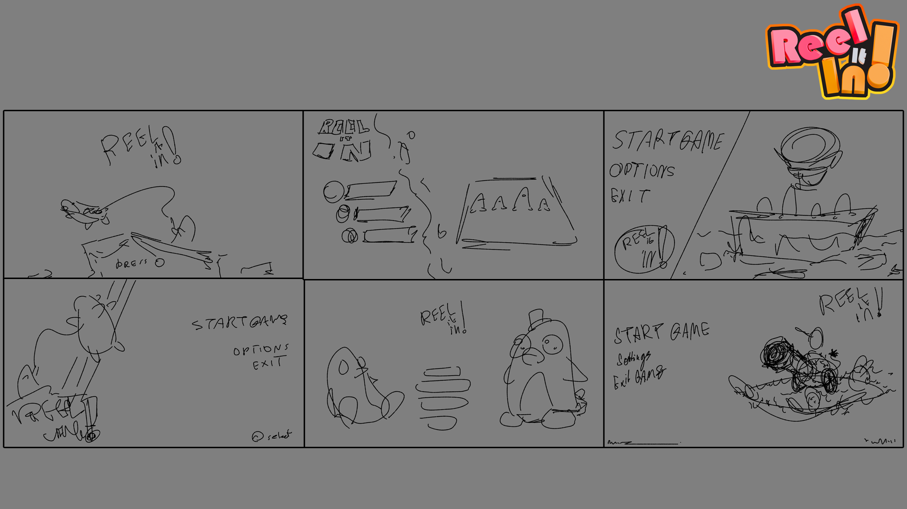

The style language is colorful and saturated, balancing** bold color** choices with soft **gradients** and the use of halftone.  
These are some different examples of color palettes.  
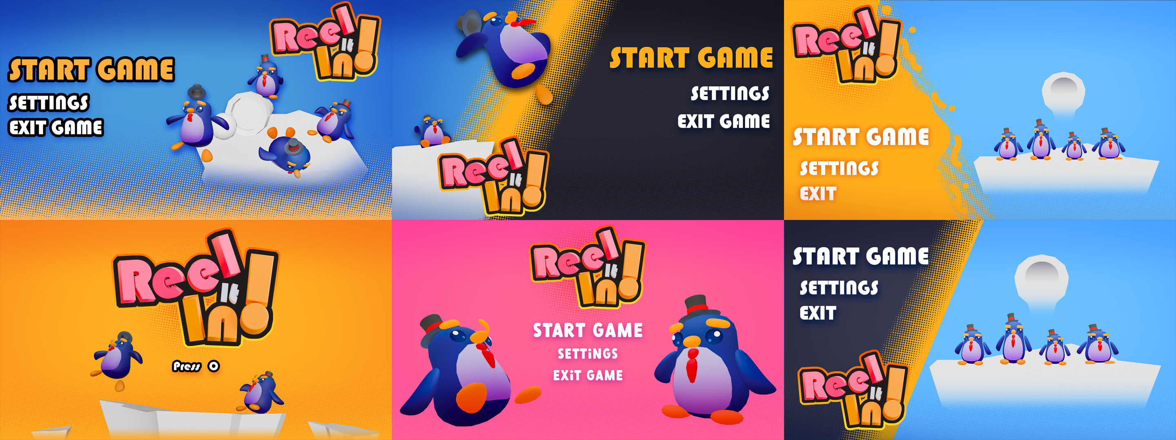

## 6.2 Menu: Penguin Selection Menu

The penguin selection menu is the **first thing** to appear when the player starts the game.  
It features 4 character slots where each can choose their penguin **color scheme** and **extras**.

The character silhouette will be assigned automatically.  
The choice of color will be simultaneous between all the players.  
Once the player has chosen their color, they have to press A to confirm.

### Layout

The 4 penguins are next to each other.

On top of their head their player number.  
Under their feet the different palette options as small squares with the main and secondary color tone.  
The color palettes can be selected by pressing X buttonon them while hovering with the right joystick  
To choose the extra accessories the players can use the right and left cross button to choose between the different options.  
This is an example.

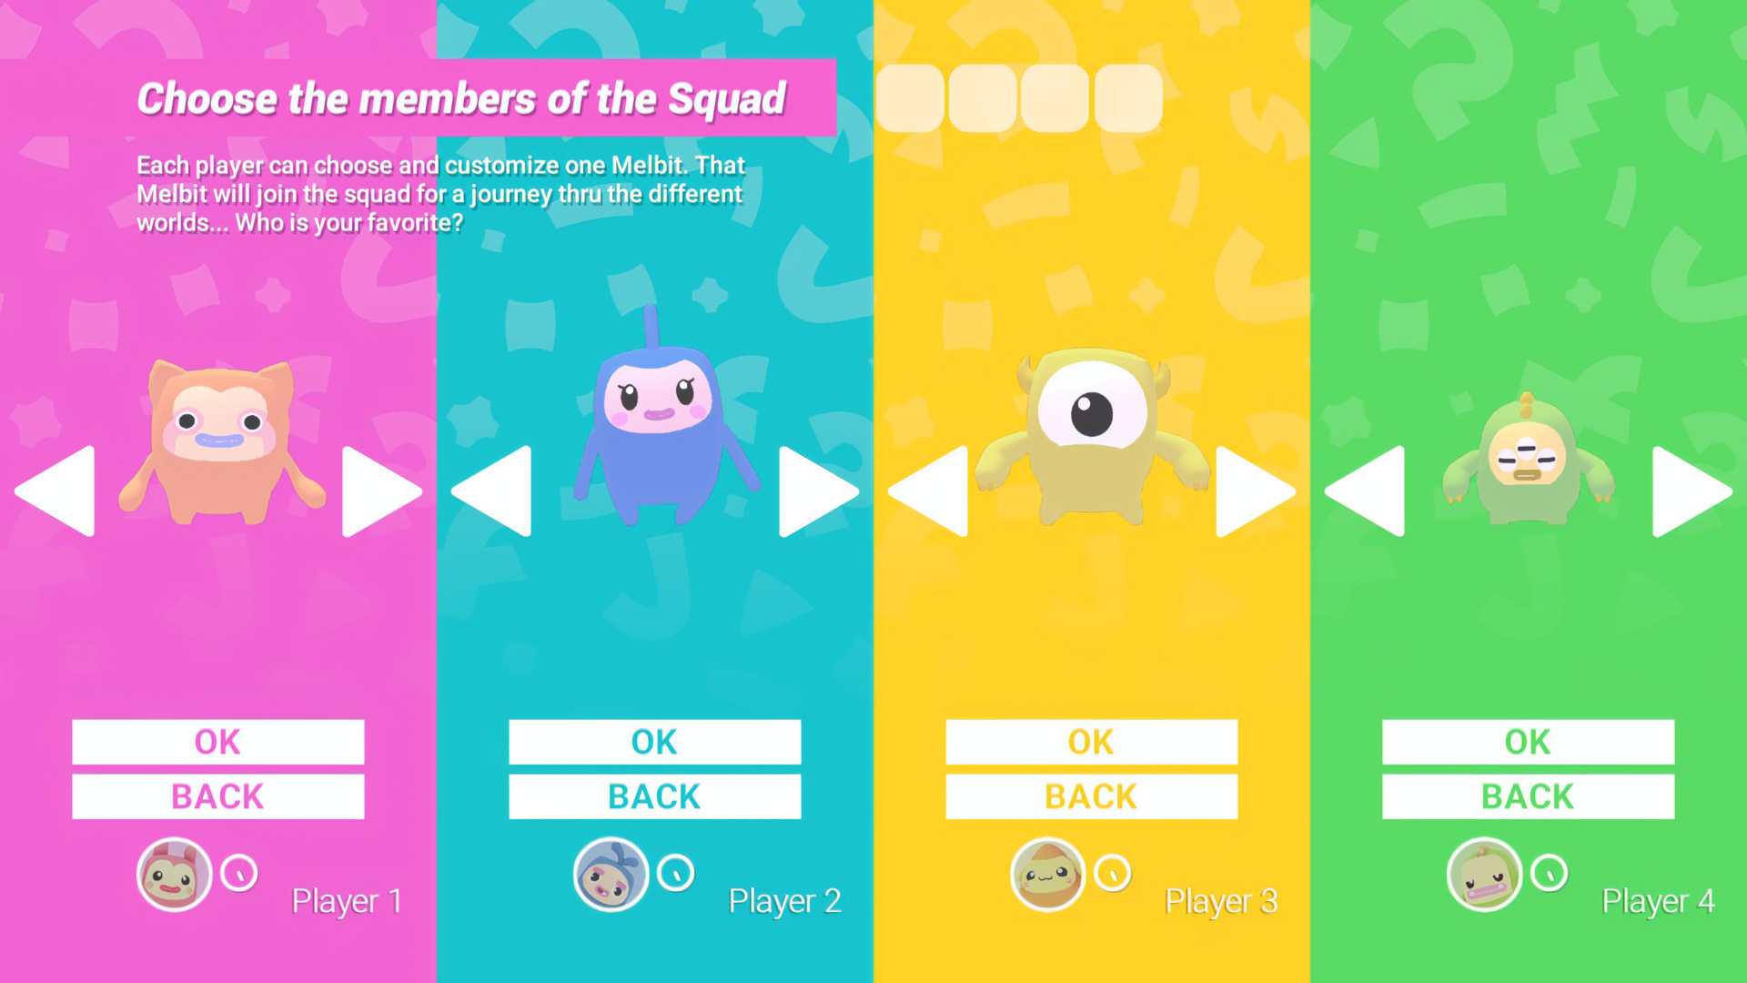

Each player has a different color for their joystick pointer.  
Once everyone has confirmed their character, a big start button appears over the whole screen, blurring everything that is behind. If one of the players presses A button, the game starts.

If the players wish to go back, they can press B button

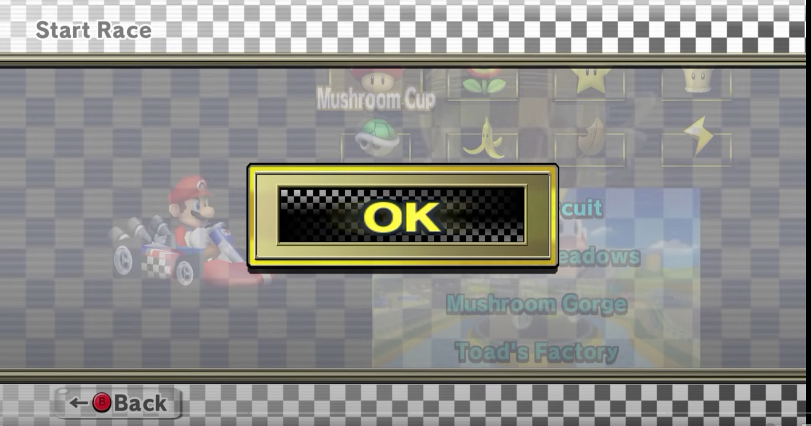

### Looks

The character selection menu roughly follows the same style and color conventions as the [Element Menu: Start Menu](https://app.hacknplan.com/p/217307/gamemodel?nodeId=25&nodeTabId=1) .  
It features a light colored background with small white penguin silhouettes panning left to right.  
The character meshes are the same used in game with no extra added details.

### 6.2.1 Cutscene: Cannon assignment (stretch goal)

When the players start the game, the character selection menu becomes the stage for our cutscene.

### Scene

The cannon falls from the top of the screen right next the penguin who got assigned as cannoneer.  
The screen shakes briefly and the penguins hop in response.  
The cannoneer's face turns angry.  
The other penguins look at him and slowly make their way out of the screen.  
Cut to black.

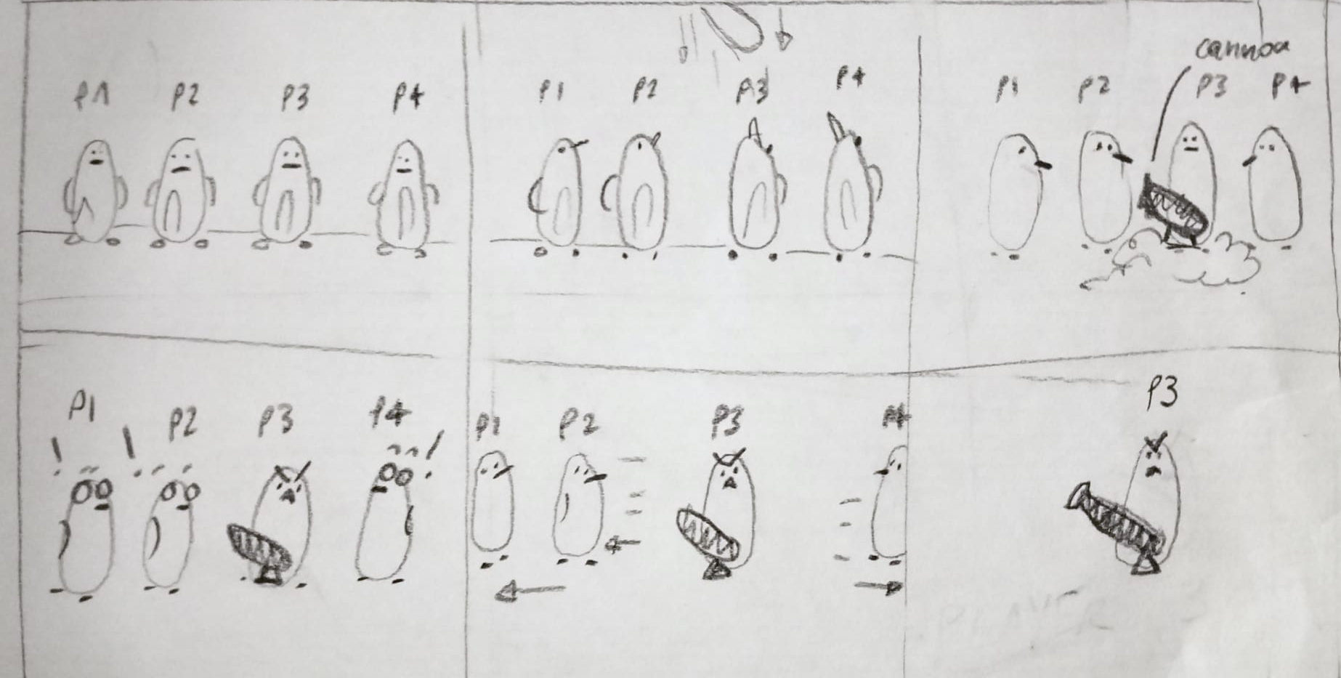

## 6.3 Menu: HUD

The main game HUD will serve as a tracker for the players to check:

1. Who is **currently** playing as the cannoneer
2. What is the **score**  of all the other players
3. Which **powerups** are enabled on all the other players

### Layout

The HUD will be in the 4 corners of the screen, displaying the 4 players and showing who is the cannon.  
It also has the timer and score implemented in it at the top.

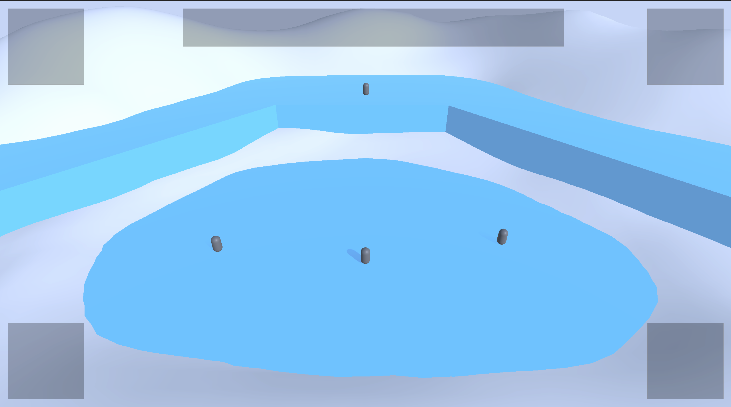

## 6.4 Menu: Settings Menu

The settings menu is simple and straightforward. Since we are making a stylized coop game we don't need resolution or quality settings.

### Layout

The settings are the following:

**AUDIO**

* Sound volume (Slider)
* SFX volume (Slider)

**GAMEPLAY**

* Controller vibration (Toggle)
* Input key mapping

**OTHER**

* Credits
* Itch.io link for review

### Looks

The style and font are the same as the main menu. The background picture is the same.  
The menu buttons appear on the left side of the screen.  
This is an example.

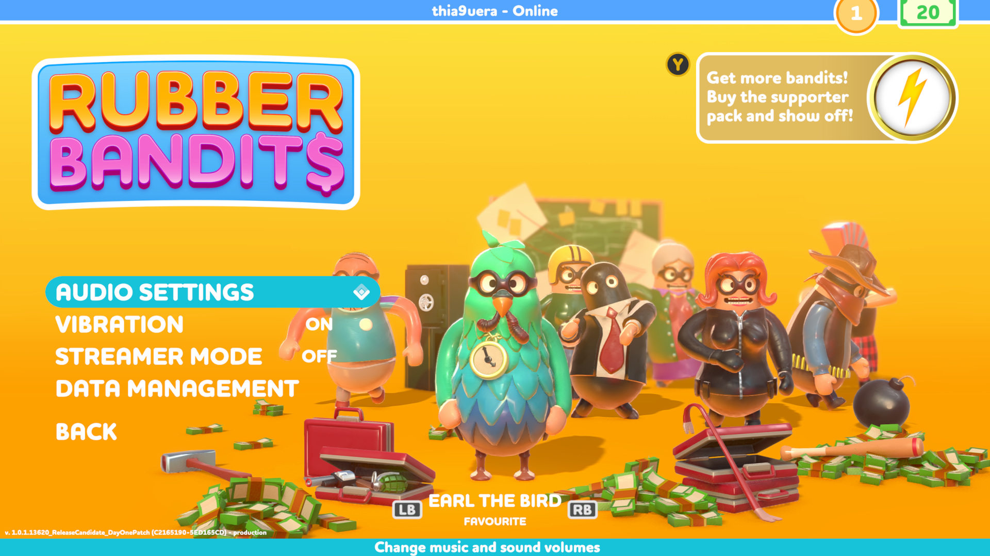

## 6.5 Menu: End screen/Leaderboard

### Layout

* By the end of the round, the leaderboard is displayed.
* The ranking is done according to **everyone's score**
* Specific keywords can be displayed under each player depending on their play style
  + People's hero for the players with the most saves
  + Agent of evil for the players that sabotaged the most runners
  + Cannon maniac for the players having the most cannon time
  + Independent warrior for the players that never got saved by others, but was never the cannon
  + Lone wolf for the players that never tried to save or sabotage anyone

The leaderboard is displayed on a wall in a small static scene. The penguin characters are present and looking at it. The last cannoneer is sitting on top of the cannon.  
After 5 seconds, a NEXT button appears on the bottom right. If one of the players clicks on it, the leaderboard fades to black and the main menu appears.

### Looks

The screen will have a similar layout to the leaderboard in LittleBig Planet:

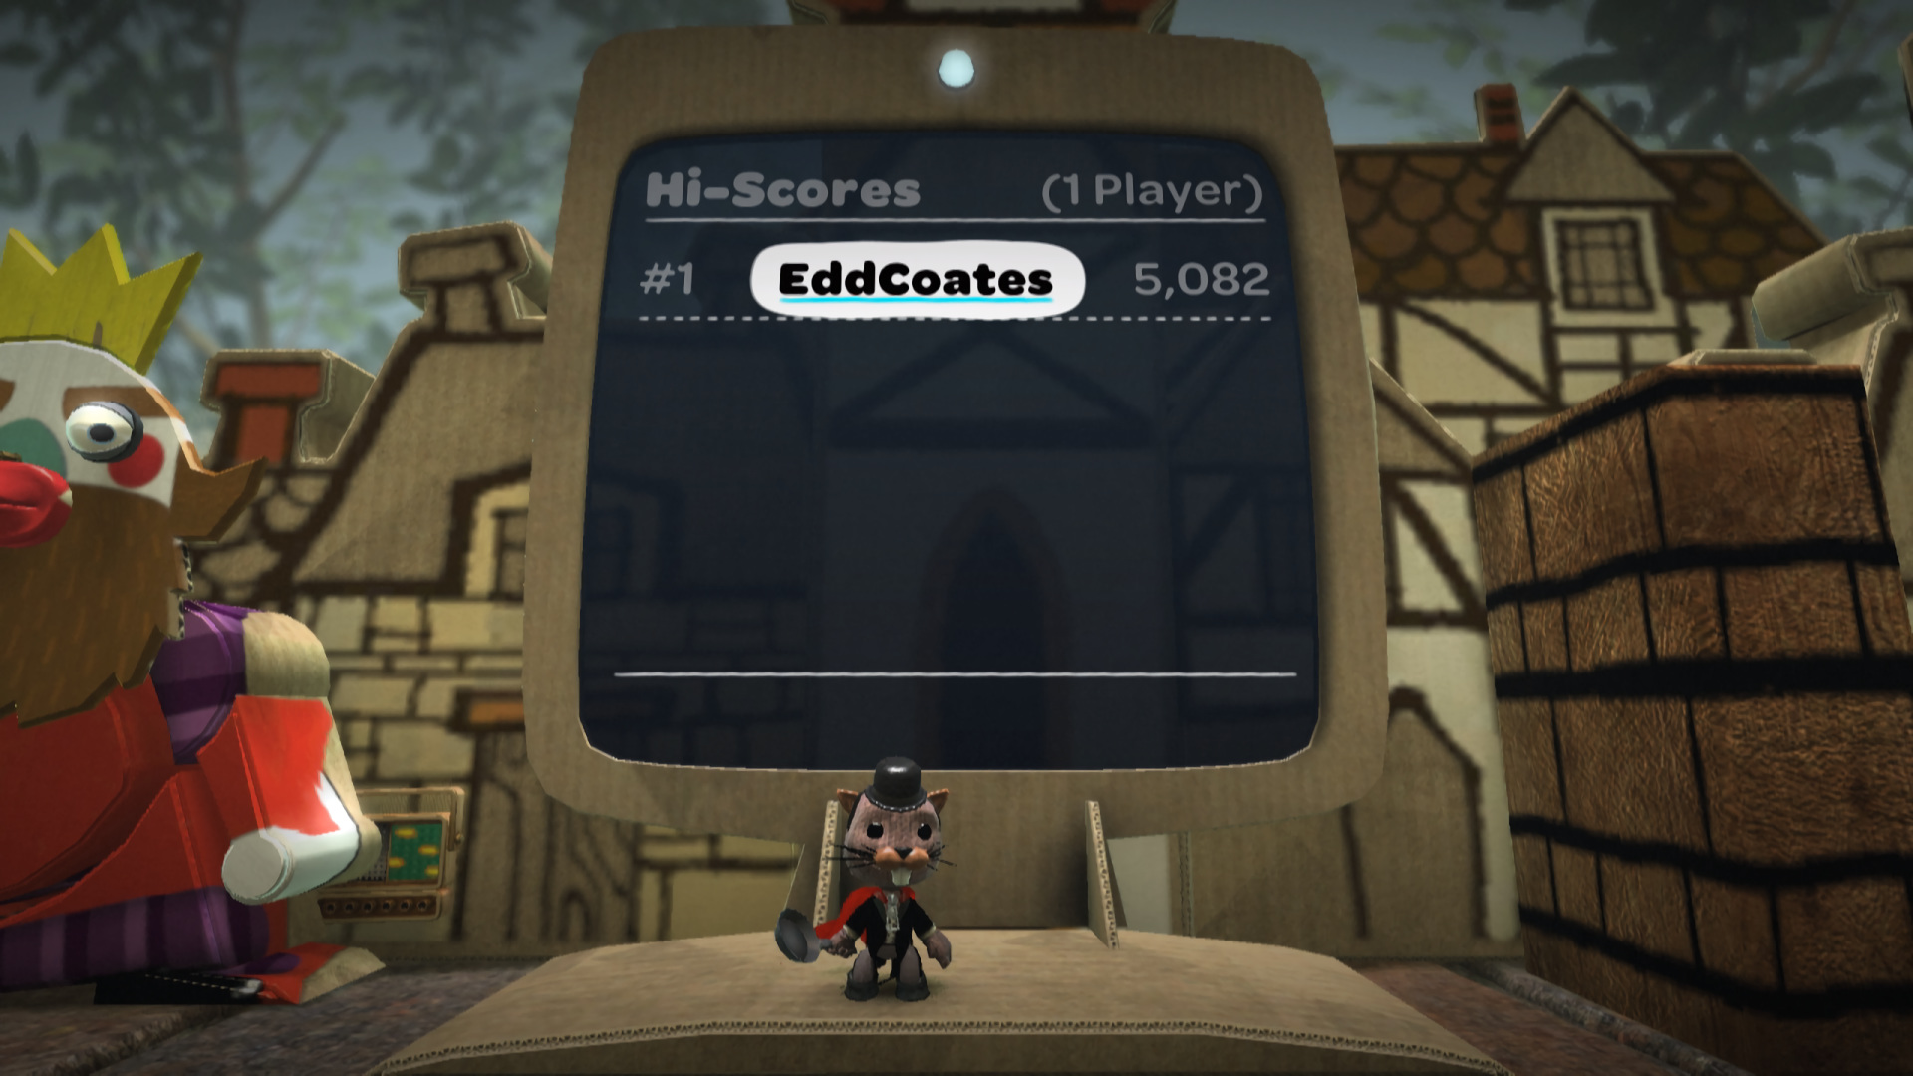

Rather than it being a plain flat screen, it's going to be treated as an end-game sequence, transitioning the players from the immersion of the gameplay back to the main screen.

# 7 Business

## 7.1 System: Marketing

For marketing we mainly use **Itch.io**. We write weekly dev logs hoping to get some people interested in our game, and we describe our game briefly and shortly on the [homepage](https://gelearthur.itch.io/group16reelitin)with a trailer and some screenshots.